**Lesson02 Course Structure**

**Notes: -**

**1-we will get Azure CLI, C# .Net**

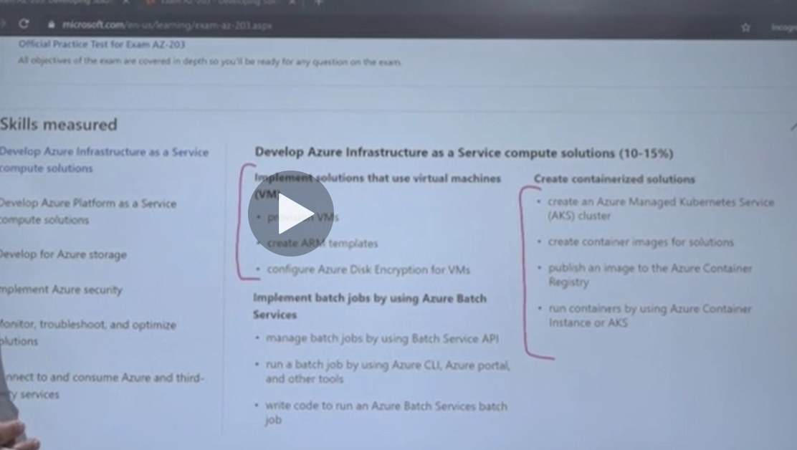

**For your practice activities, make sure to**

1. Create an Azure Free account to work with Azure based resources.

2. Download the resources in the lab. These resources contain .Net code. Research through the code and see how it works with Azure services.